BEM (Block Element Modifier)

B (Block) = A standalone entity that is meaningful on its own.

E (Element) = A part of a block that has no standalone meaning and is semantically tied to its block

M (Modifier)= A flag on a block or element. Use them to change appearance or behavior.

BEM (Block Element Modifier) is CSS as a naming convention for writing modular and maintainable code. BEM helps developers to create a consistent and predictable naming structure for CSS classes, making it easier to understand and modify the code over time.

BEM's approach involves breaking down web pages into small, reusable components or "blocks," which contain one or more "elements" and may have additional "modifiers" that change their appearance or behavior. These components can be combined to create complex layouts and designs, while still remaining easy to manage and update.

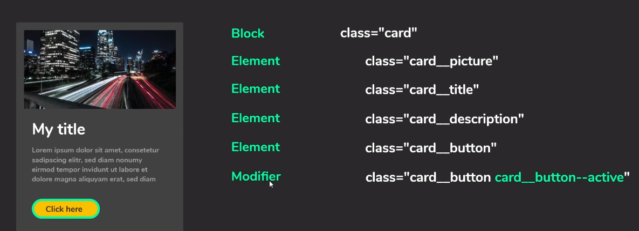

Reference <https://www.youtube.com/watch?v=er1JEDuPbZQ>